Name: Gekonge Duke Omayio (PhD) | Ph.D in Food Science and Technology
Title of thesis: Production, utilization, and processing of Kenyan guavas: Development of nutrient-enriched guava nectars from local varieties.
- Summary of work done
Assessment of the current status of guava value chains in
Kenya while contributing to guava value addition by developing nutrient-enriched guava nectars
- Key findings
Despite the country's favorable climatic conditions for guava farming, there is a critical lack of commercial production and non-existent industrial processing. Neglect of the Kenyan guava results in losses for more than 75% of guava farming households, whose annual production exceeds 11Mt. Raw guava fruit sales were extremely poor, with prices ranging from Ksh 2 to 10 per kg. However, the processed guavas were well received by consumers, and based on market pricing for similar products, the developed products fetched Ksh 200-250 per litre, translating to an average profit of Ksh 120-160 per kg of processed fruit. A food-to-food fortification using moringa leaf extracts resulted in nutritionally superior nectars with boosted micronutrients (zinc and iron), macronutrients (calcium and potassium) and phytochemicals (phenolics, flavonoids and antioxidant activities).
Take home message  This study resulted in the development of nutritious guava nectars and demonstrated that adopting low-cost processing techniques for the Kenyan guava at the household and smallscale levels would result in nutrient-enriched guava beverages, which could aid in strengthening guava value chains by improving guava farmers' livelihoods and consumer access to processed fruits when they are out of season. |  | 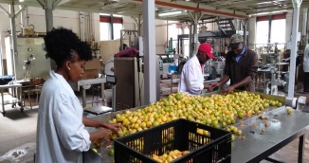  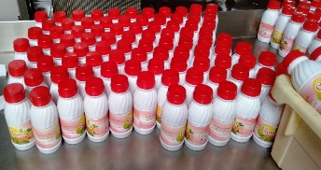  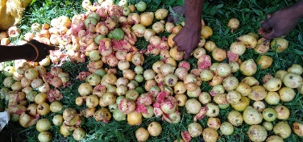  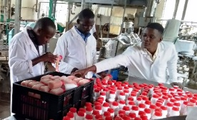  Figure 1: Reduction of guava fruit losses through processing
Most interesting part about my MSc/PhD study program that you would like the world to know and/or will make others to be interesrested/motivated to pursue a similar program/research
The Kenyan guava crop has a high potential for improving farmer livelihoods; however, there is a need for households, MSMEs Processors, and food processing startups to adopt the developed processing techniques. It is recommended that the nutritional qualities of the resulting products be improved through food-to-food fortification with other fruits or edible plants, which provides an opportunity for nutritional security, particularly among vulnerable members of resource-constrained communities such as women and children.. The fact that guavas are culturally acceptable in the areas where they grow in Kenya, combined with low pricing and ease of access, makes the fruit a nutritionally inexpensive alternative to purchasing other locally processed fruits, which are often expensive. The process and the resulting products have been patented through the University of Nairobi Intellectual properties office, Patent No. KE/UM/2019/1238.

