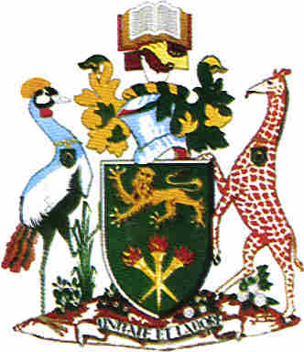

**UNIVERSITY OF NAIROBI**

**DEPARTMENT OF FOOD SCIENCE NUTRITION AND TECHNOLOGY**

**MENTORSHIP/ORIENTATION PROGRAMME FOR FIRST YEARS 2025/2026**

**VENUE**: **ANP MSC LECTURE THEATRE** **DATE**: 02/09/2025

|  |  |
| --- | --- |
| **TIME** | **ACTIVITY** |
| 11.15AM | All to be seated |
| 11.30 AM | Opening prayer/National Anthem |
| 11.35AM | Introductory remarks   * Academic staff * Departmental Admin * Chief Technologist |
| 12:00PM | Chairmans Address   * Welcome remarks by the Chair of Department * Introduction of Department academic staff * Key Note Address by the Chairman |
| 12:30PM | Election of Class representatives/ Recognition |
| 12.50 PM. | Closing Prayer |
| 1.00 PM | Department Tour led by Technologists |

**WELCOME**